Title [Arial 14 pt., bold, centered]
Surname, Name^{1,*}, Surname, Name²
(1) Affiliation, Address, City, Country
(2) Affiliation
*corresponding author: e-mail@e-mail.com

INSTRUCTIONS:
The text should be written in English using Arial (11 points), line spacing 1.5 and justified.
The maximum abstract length is ONE PAGE, including Figures or Tables (if necessary).

Please, submit your abstract in word format to this link before the end of 15th May. If you have any trouble with the abstract submission, please send it to amcinbio@gmail.com.

OPTIONAL 1 FIGURE GOES HERE
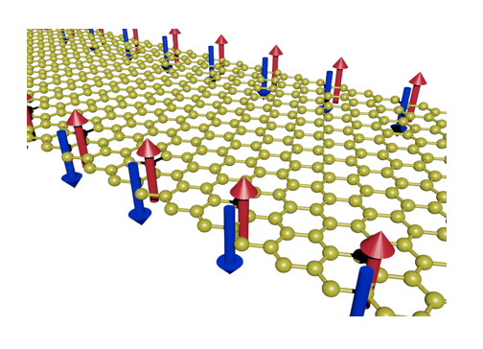
Figure Caption. 2 lines top

Acknowledgement of Funding goes here.

References:
[1] A. Author, B. Author, and C. Author, Journal, Volume, Page (Year).
[2] A. Author, Title of Book, Publisher, City (Year).
[3] A. Author and B. Author, Conference, Dates, City, Country, Page (Year).

